# CS 255 System Design Document Template

This template lays out all the different sections that you need to complete for Project Two. Each section has guidance to prompt your thinking. You will need to continually reference the interview transcript as you work to make sure that you are addressing your client’s needs. There is no required length for the final document. Instead the goal is to complete each section based on what your client’s needs are. Remove this note when you are finished, and replace all bracketed text with the relevant information.

## UML Diagrams

### UML Use Case Diagram

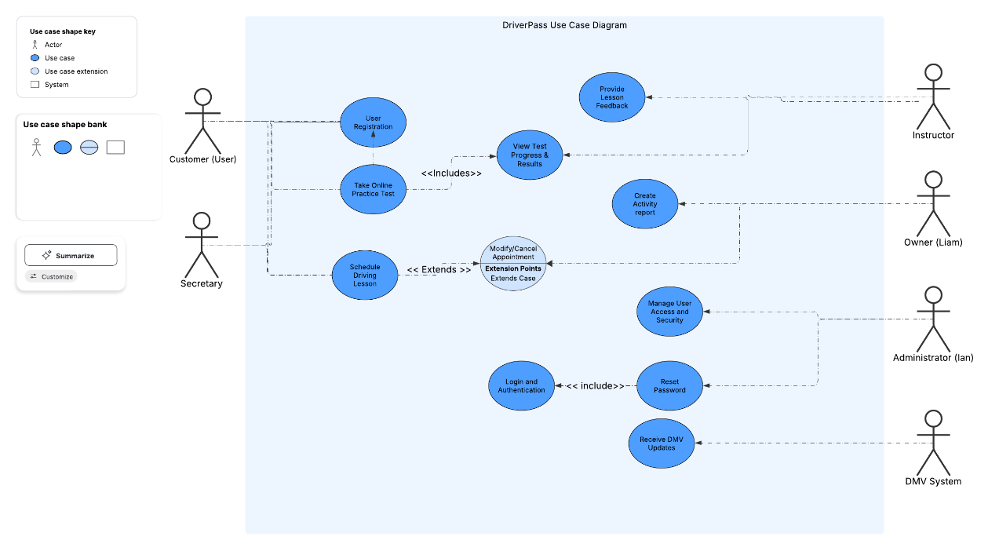

### UML Activity Diagrams

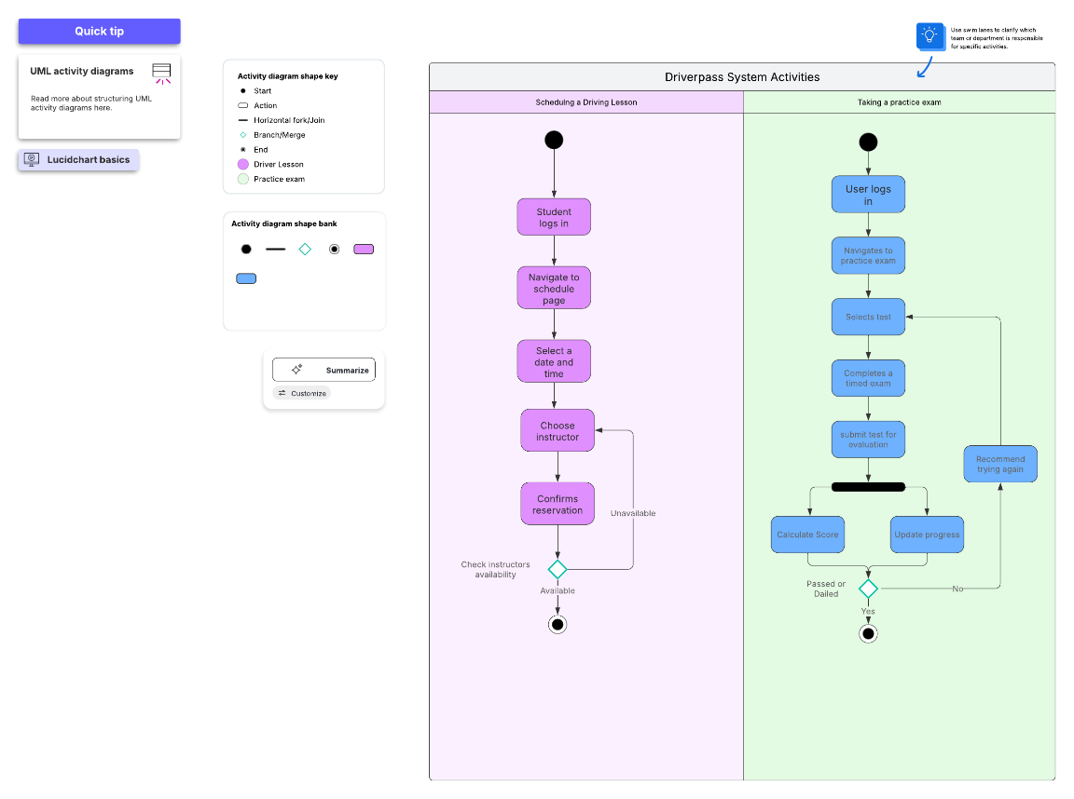

### UML Sequence Diagram

### UML Class Diagram

## Technical Requirements

*The hardware requirements would include a Cloud-based server for hosting the DriverPass system. A secure storage system for user data and test records. Computers and mobile devices for user access.*

*The software requirements would be a web-based application framework. As well as a secure authentication and encryption protocols and a database management system.*

*The tools would most likely include HTML, CSS, JavaScript. For backend work systems such as Java, or Python. A database such as MySQL, or MongoDB. A hosting network, and a form of multi factor authentication.*